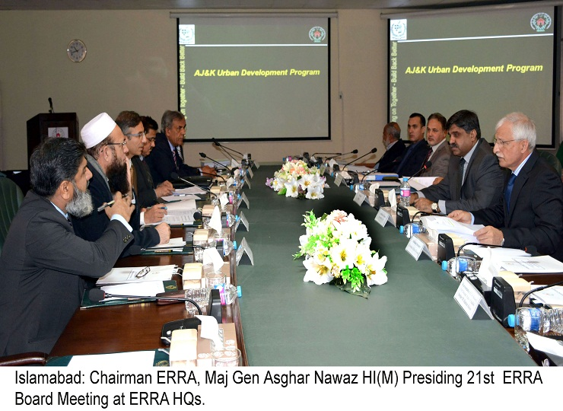

Press Release

Islamabad: 20-08-2016

21st ERRA Board Meeting Held at ERRA Headquarters Today

21st ERRA Board Meeting was held here today. The Board Meeting was chaired by Chairman ERRA Maj Gen Asghar Nawaz and was attended by 10 board members, including Acting Deputy Chairman ERRA, Additional Finance Secretary and representatives of Planning, Development and Reforms Division, Economic Affairs Division, Additional Chief Secretaries (Development) AJK and KP besides members from the Civil Society of Earthquake affected areas. Agenda points related to ERRA’s financial matters of Urban Development Program were discussed and approved by the Board.

End

